React.js Component Creation

Name : Padyala Sowmya Sri

Email :padyalasowmya2003@gmail.com

Phone no: 8179733629

Roll NO : 20NN1A1246(IT)

College Name : Vignan’s Nirula Institute of Technology and science for women

**source code :**

**CARD COMPONENT :**

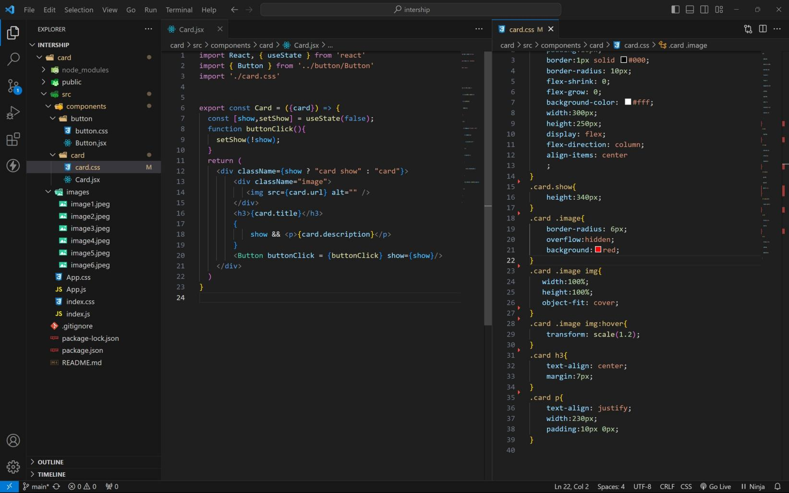

BUTTON COMPONENT :

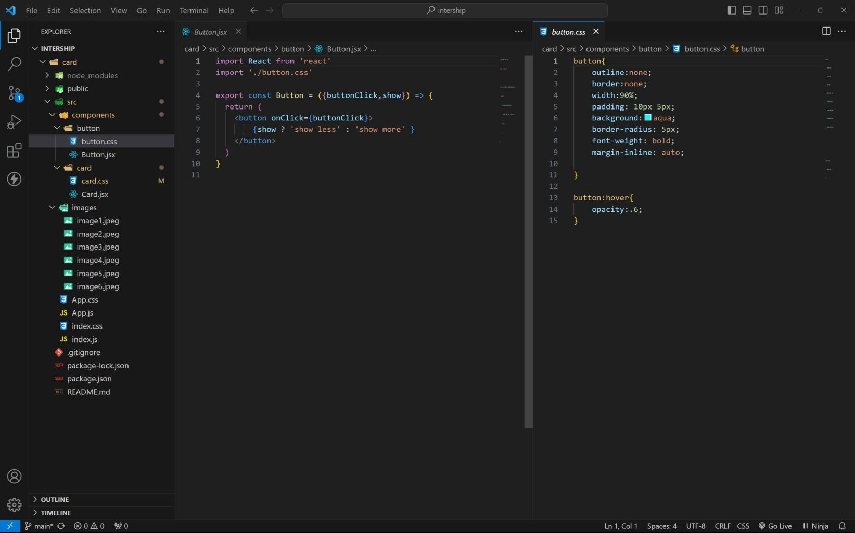

APP COMPONENT :

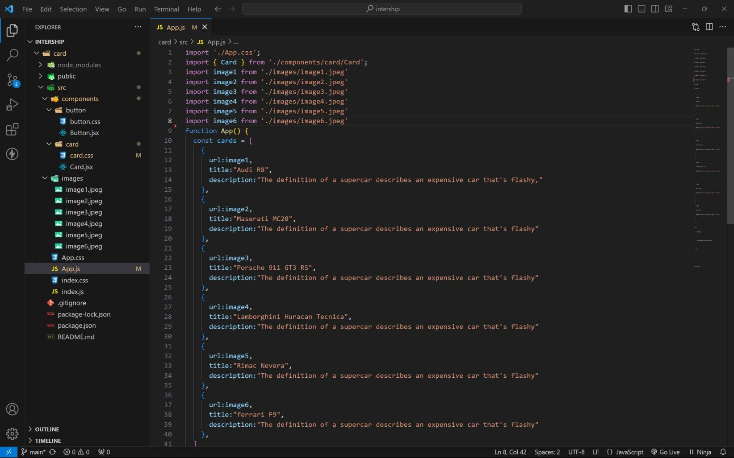

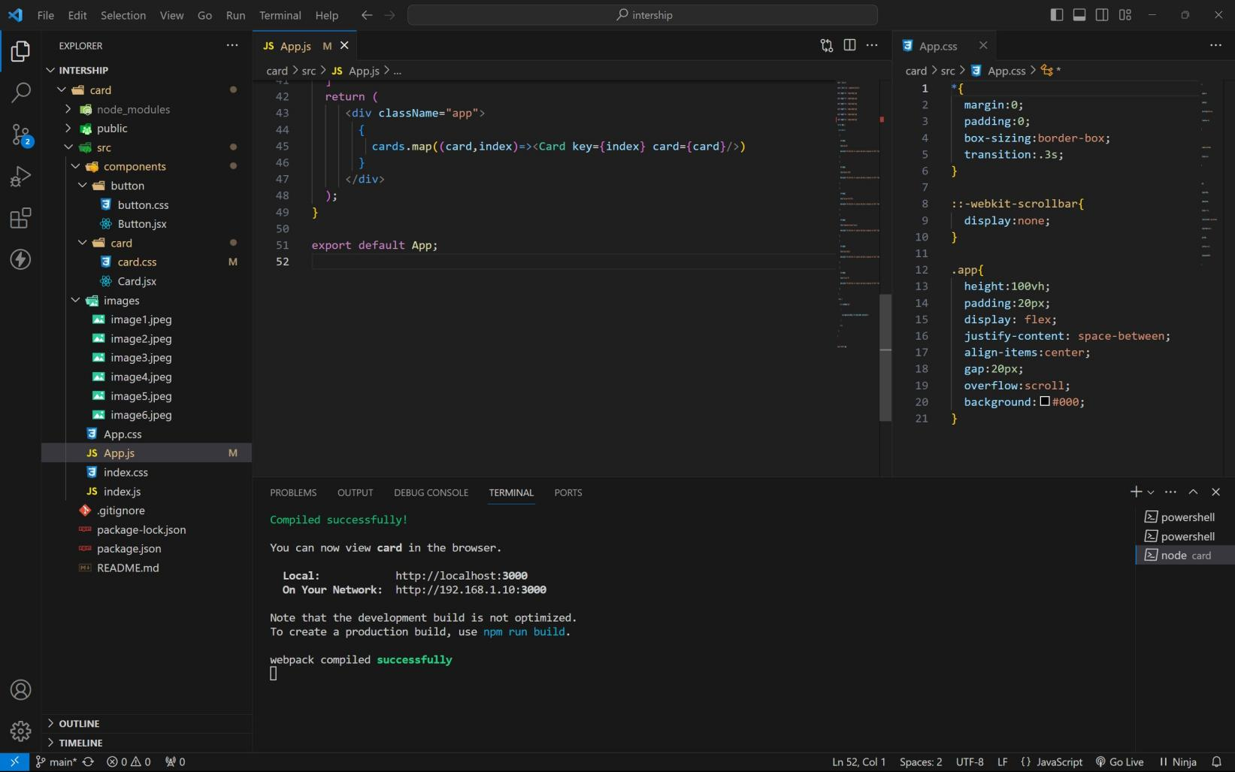

approach :

1 . initially taking an array of objects like below

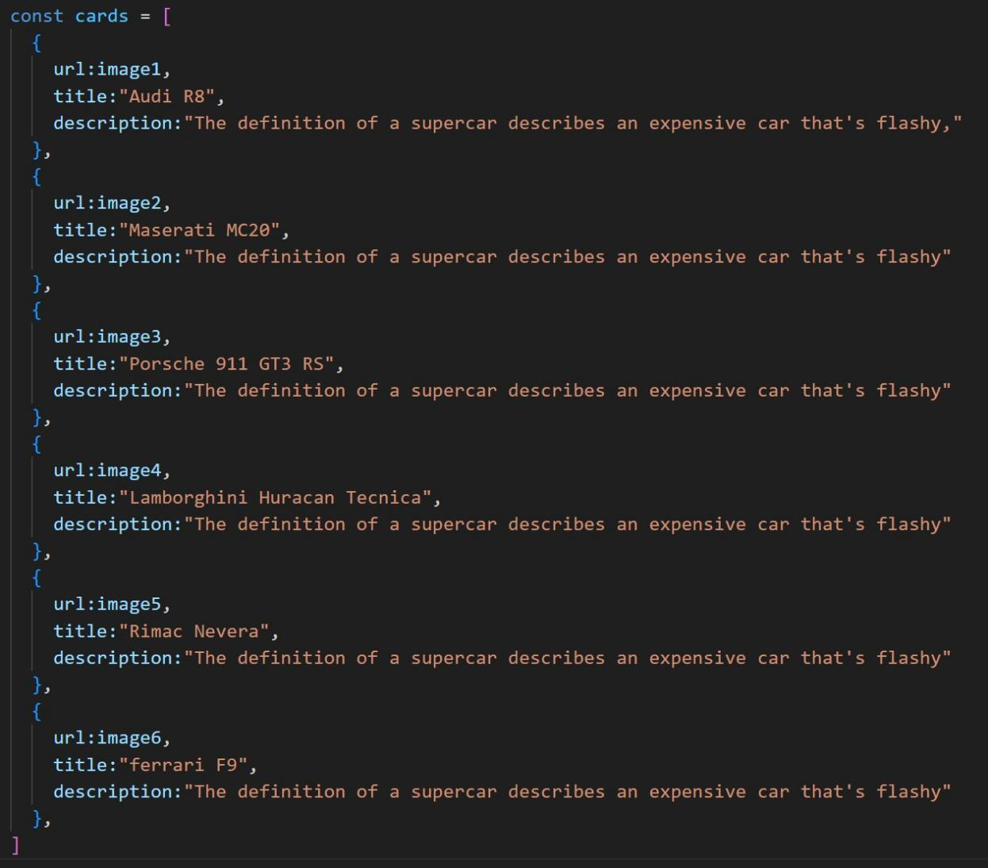

1. **. Passing this card array to child (card component) of App component by using props;**
2. **. getting data as argument like {card} in card component.**
3. **. in card component i use one state [show, setShow] to get extra info as description.**
4. **. When we click the button then show becomes true by assigning setShow (!show) .**

OUTPUT :

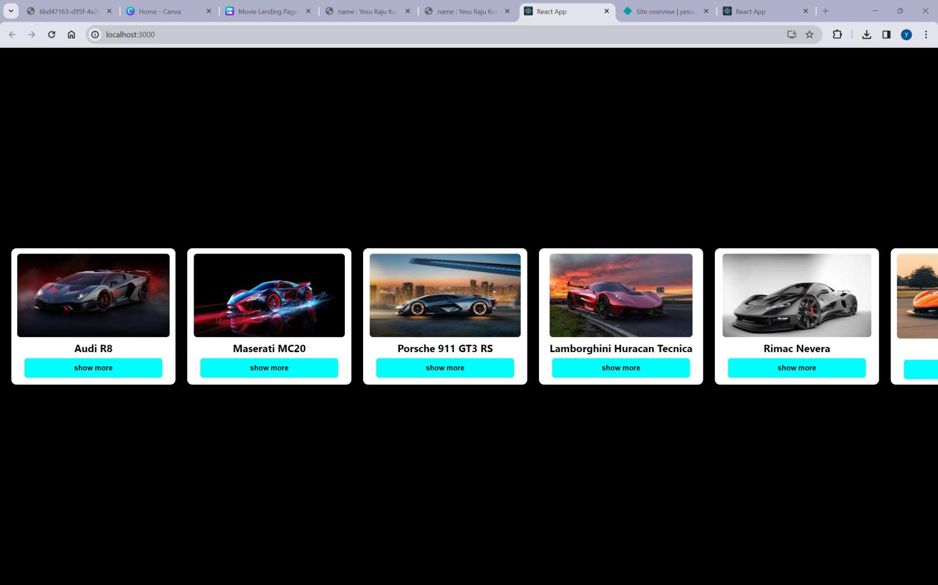

AFTER BUTTON CLICKS :

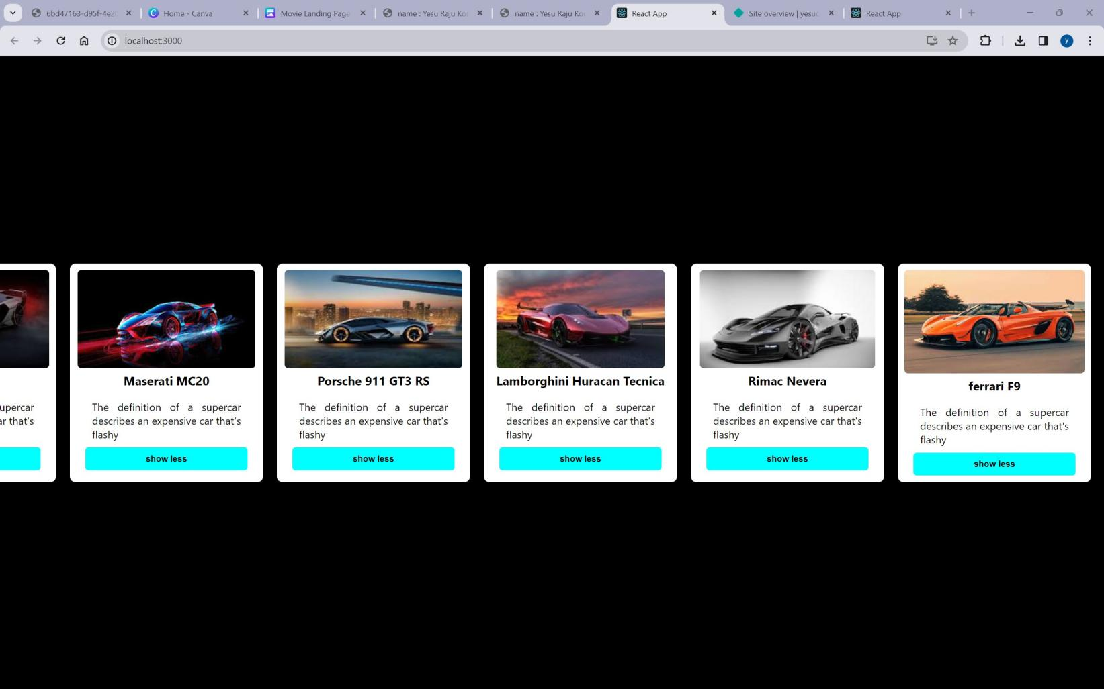

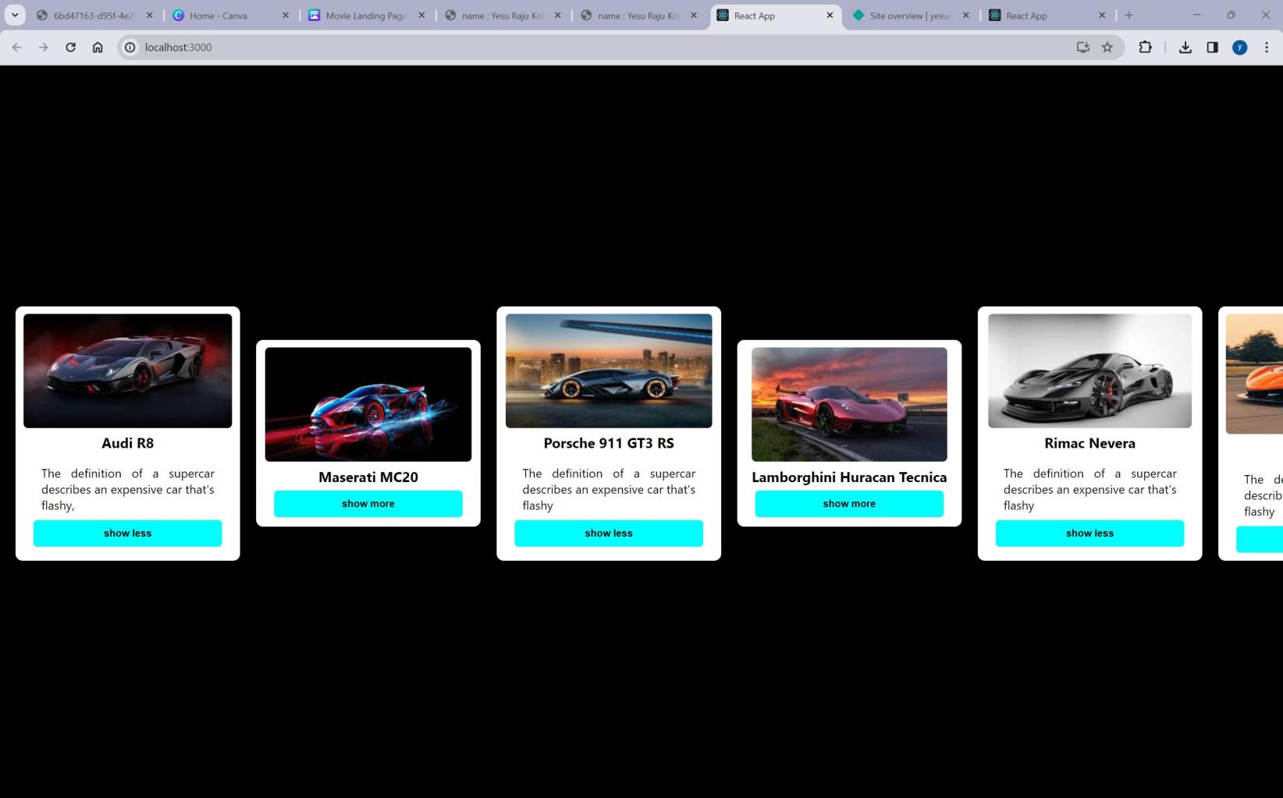

github link : [https://github.com/1246sowmya/card](https://github.com/4727yesuraju/card) livedemo : [https://sowmyacard.netlify.app](https://yesucard.netlify.app/)